Using Value Stream Mapping to Optimize My Personal Night Routine

Kristina Vasquez

Bellevue University

CSD370-J308 Secure Software Development (2247-DD)

Sue Sampson

11/24/2024

**Abstract:**  
This paper explores the application of Value Stream Mapping (VSM) to a personal routine, aiming to identify inefficiencies and improve work-life balance. The author outlines their current routine, the time management challenges faced, and the use of VSM to create a more structured and manageable evening routine. This process involves identifying technical debt, such as unproductive naps, analyzing time usage, and optimizing processes to better balance work, school, personal time, and self-care.

**Introduction:**  
Value Stream Mapping (VSM) is a lean management tool traditionally used in business settings to analyze and improve processes. However, VSM can also be effectively applied to personal life to identify inefficiencies, optimize time management, and reduce stress. After reflecting on my current schedule and reviewing the article for this week's assignment, "3 Easy Steps for Using VSM in Everyday Life," which referenced a morning routine for a value stream, I realized that the lack of a consistent routine had significantly contributed to my feelings of burnout and being overwhelmed (ConnectAll, 2024). This paper applies VSM to my evening routine with the goal of reducing technical debt, such as excessive napping, and optimizing time usage. The desired outcome is a more structured, balanced routine that enhances both personal well-being and academic performance.

**Identifying the Current State:**  
My current routine is inconsistent due to fluctuating work demands, personal commitments, and the need for recovery from stress. On weekdays, I work from 8 AM to 4 PM, with additional duties such as on-call responsibilities, deployments, and therapy sessions. On Tuesdays and Thursdays, deployments from 6 PM until late disrupt my evening routine. This lack of consistency has led to exhaustion and difficulty prioritizing tasks like homework, self-care, and socializing. The technical debt created by frequent naps—ranging from 30 minutes to 3 hours—has been a significant contributor to my fatigue, delaying essential tasks. This inconsistency has exacerbated my stress levels and diminished productivity.

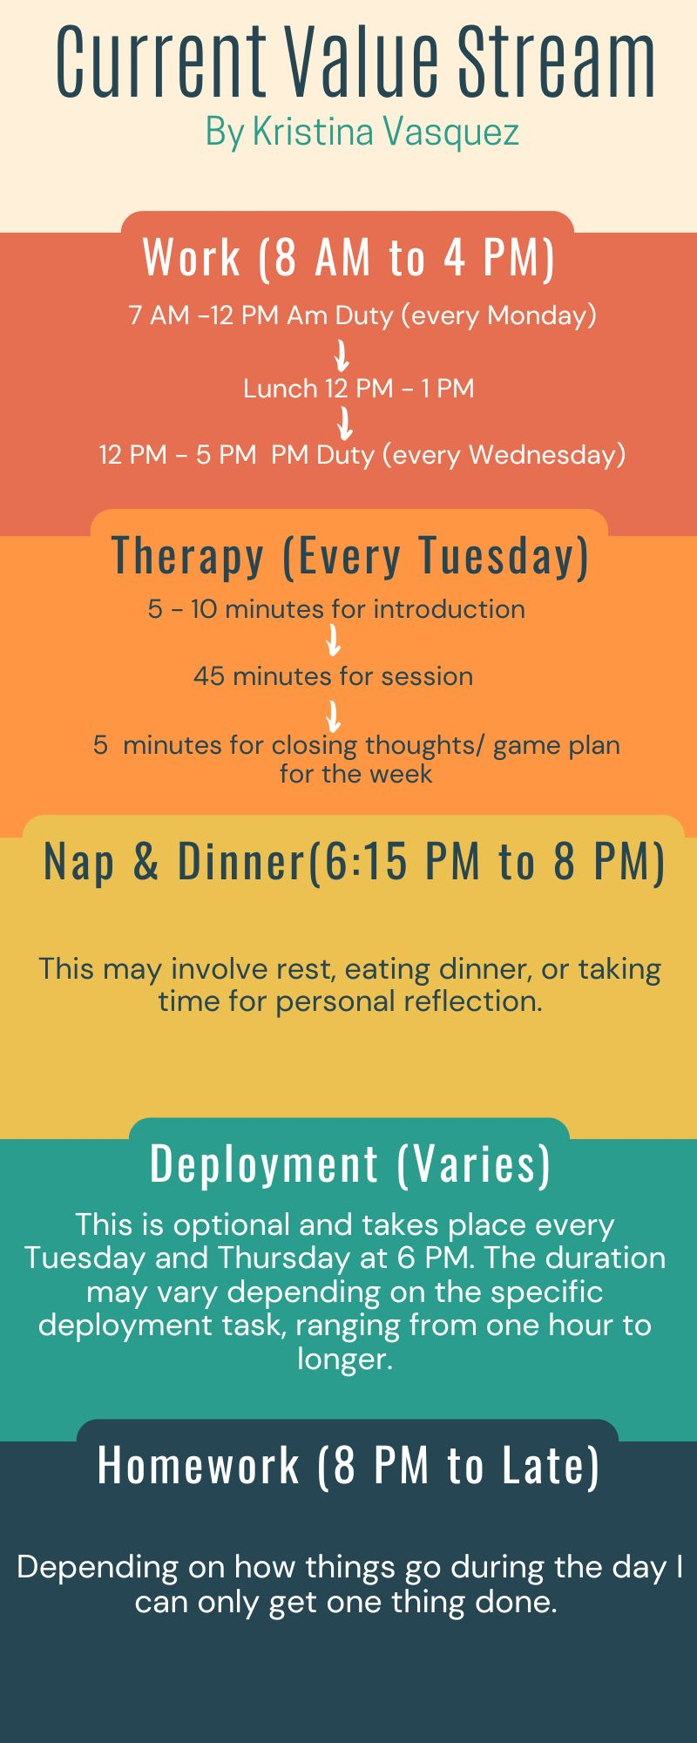

**Creating the Value Stream Map:**  
To address these challenges, I applied VSM to my evening routine, considering both wasted time and activities that provide value. The VSM highlights several key activities: work (8 AM to 4 PM), therapy (5 PM to 6 PM), deployments (6 PM to 2 AM), meals (30 minutes), and naps. Although naps provide short-term relief, they contribute to missed opportunities for productive activities like homework, exercise, and relaxation. The VSM visualizes my typical evening, identifying areas for optimization.

Lean Metrics and Optimizing the Process:  
After identifying key steps in my routine, I analyzed it using lean metrics such as lead time (the total time to complete a task), cycle time (the time spent starting and finishing a task), and takt time (the required pace of work). By tracking the time spent on each activity, I calculated the following:

* Lead Time: Total time from work completion to sleep, approximately 16 hours.
* Cycle Time: Time spent on individual tasks (e.g., homework, meals, and naps). Variability in these times indicates inefficiency, especially in homework.
* Takt Time: The necessary allocation of time for each task to ensure work, self-care, and adequate rest.

The analysis reveals that naps are the largest source of technical debt. While they provide immediate relief, they delay task completion—particularly homework—and further reduce time available for self-care or socializing. Optimizing this process involves reducing nap duration and reallocating time toward more productive activities like homework and exercise.

**Proposed Improvements:**  
The key to improving my routine lies in addressing the root causes of inefficiency. First, I plan to limit nap duration to no more than 30 minutes, providing a quick energy boost without disrupting evening tasks. Second, I will structure my evening by allocating fixed time blocks for homework, dinner, and self-care, ensuring balance during high-stress periods. Third, I will reduce time spent on non-productive activities, such as excessive screen time, and focus more on activities like exercise and relaxation to enhance overall well-being.

**Conclusion:**  
Applying VSM to my personal routine has proven to be a valuable exercise in identifying inefficiencies and areas for improvement. By analyzing my evening routine through lean principles, I can reduce the technical debt caused by naps and unproductive time. This will lead to a more structured, balanced routine that supports both my personal well-being and academic performance. VSM offers a practical approach to optimizing everyday life, ultimately helping me manage work, school, and self-care more effectively.

Citations:  
ConnectAll. (2024). 3 Easy steps for using VSM in everyday life. Retrieved from <https://www.connectall.com/3-easy-steps-for-using-vsm-in-everyday-life/>